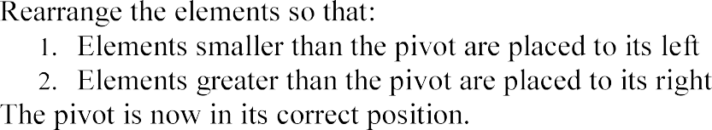
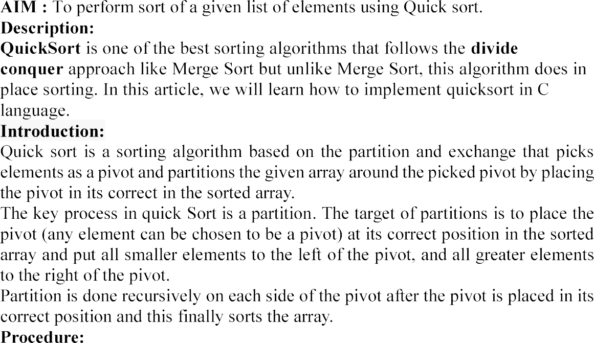
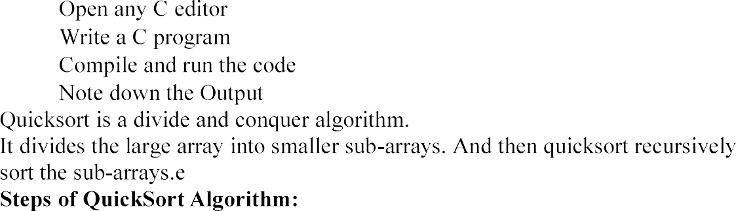
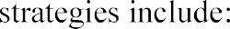

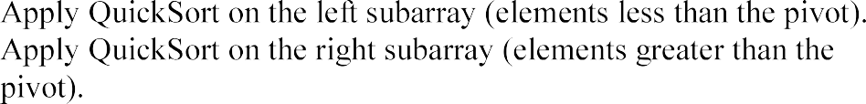

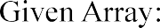
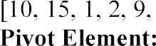
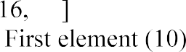
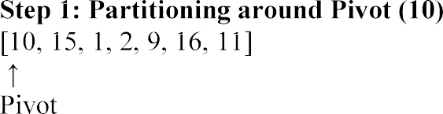
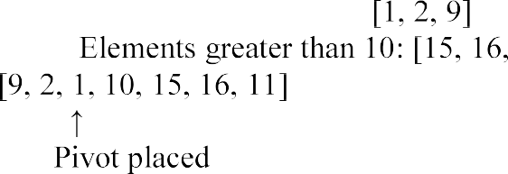
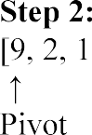
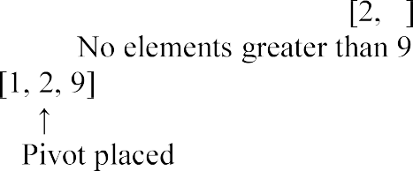
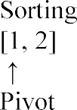

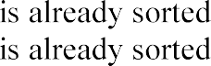
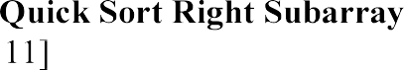
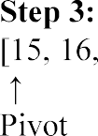
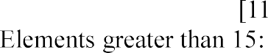

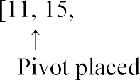
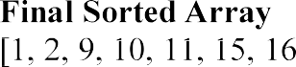

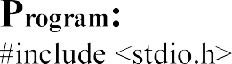
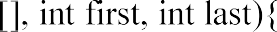
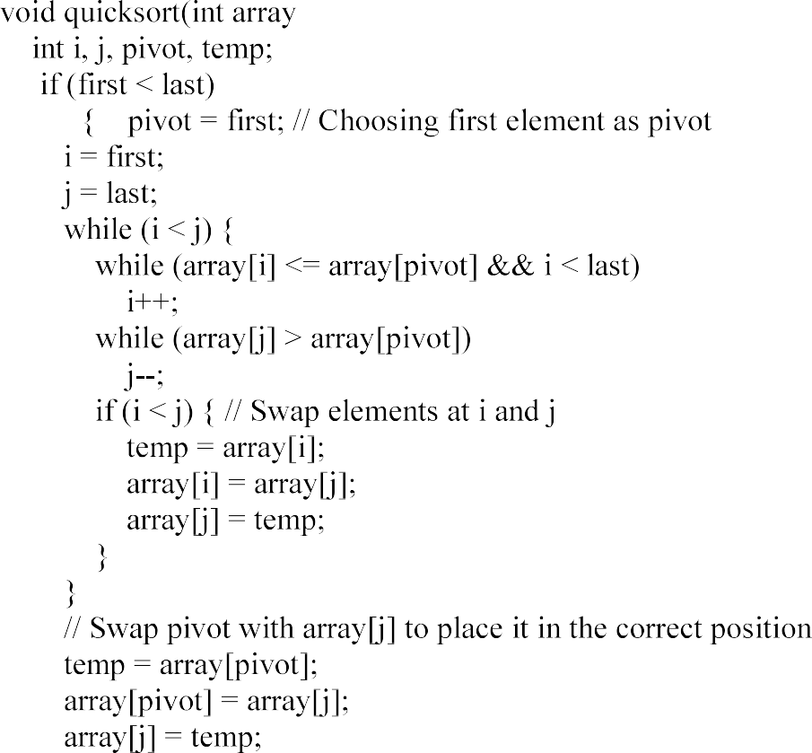

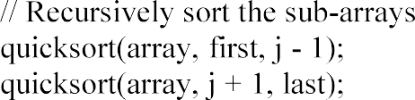
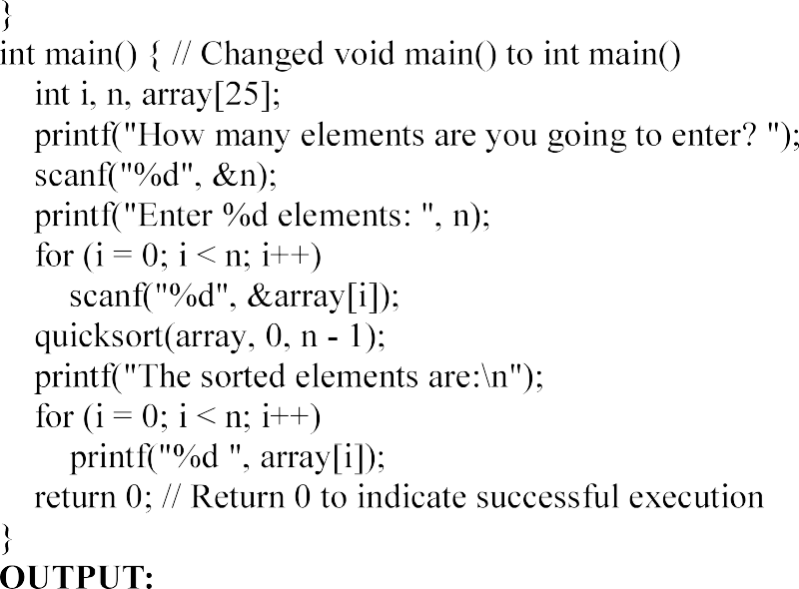

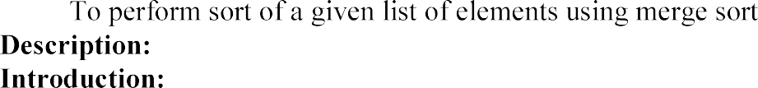

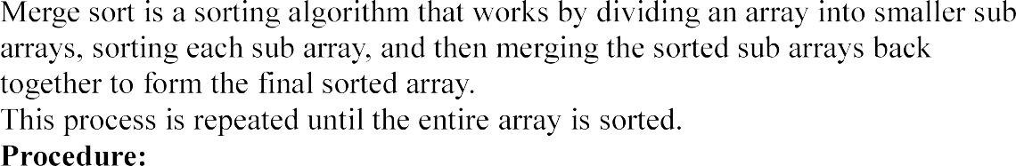
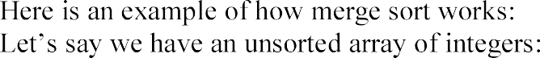
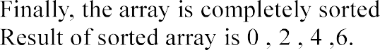
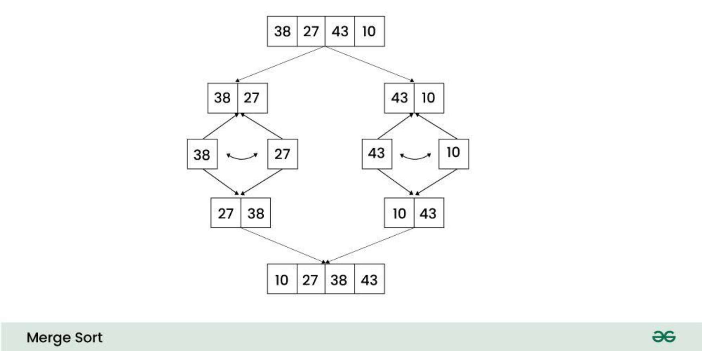

Aspect | Complexity
Time Complexity | O(n log n)
Space Complexity | O(n)
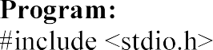
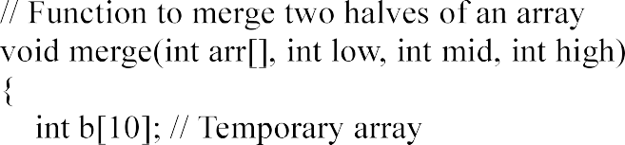

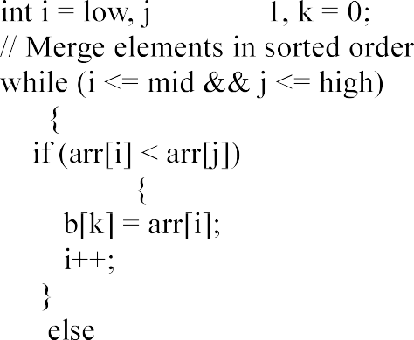

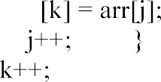

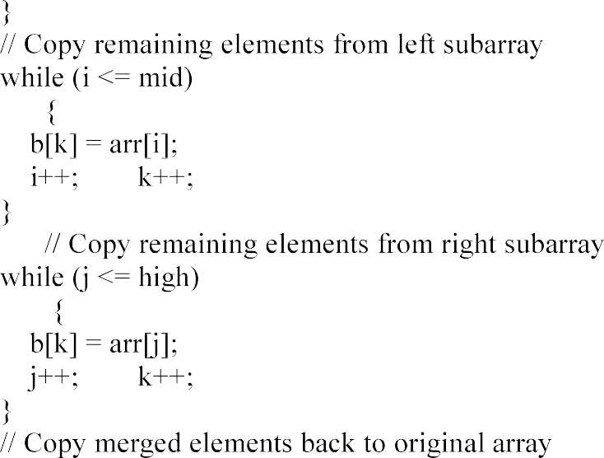
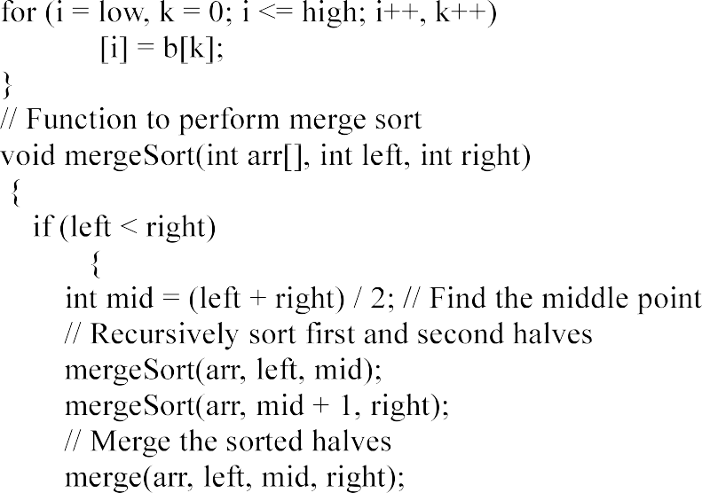



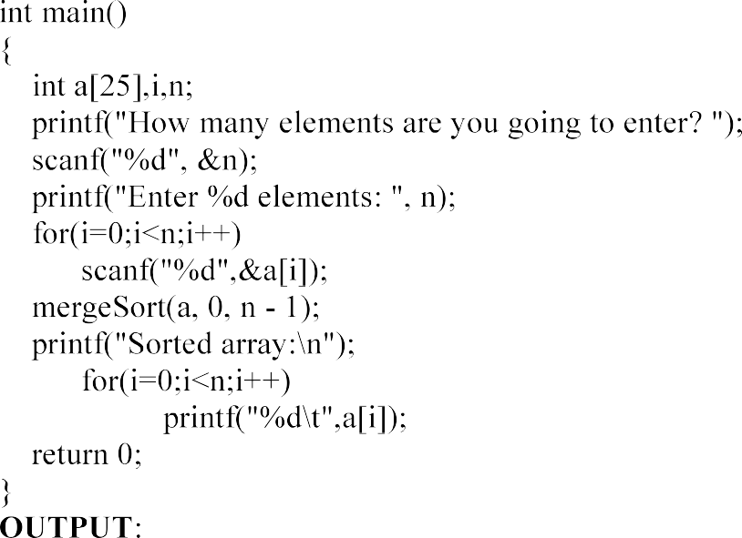
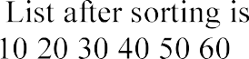

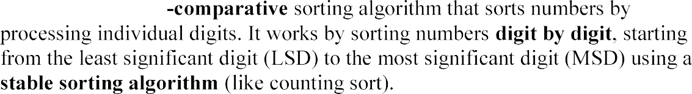
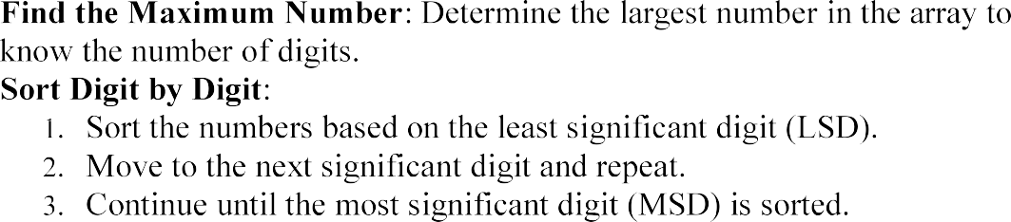

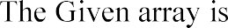
0 | 1 | 2 | 3 | 4 | 5 | 6 | 7 | 8 | 9
432 | 8 | 530 | 90 | 88 | 231 | 11 | 45 | 677 | 199
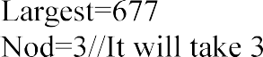
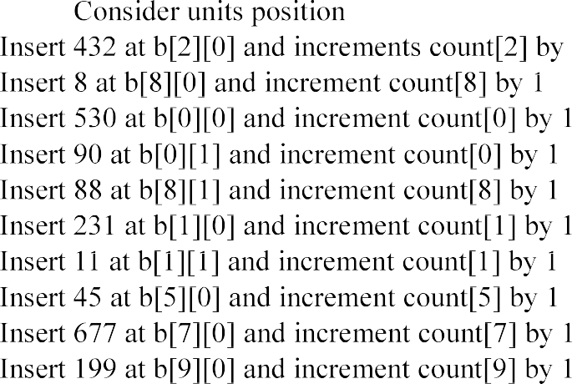

 | Count | b | 0 | 1 | 2 | 3 | 4 | 5 | 6 | 7 | 8 | 9
0 | 2 | 0 | 530 | 90
1 | 2 | 1 | 231 | 11
2 | 1 | 2 | 432
3 | 0 | 3
4 | 0 | 4
5 | 1 | 5 | 45
6 | 0 | 6
7 | 1 | 7 | 677
8 | 2 | 8 | 8 | 88
9 | 1 | 9 | 199

0 | 1 | 2 | 3 | 4 | 5 | 6 | 7 | 8 | 9
530 | 90 | 231 | 11 | 432 | 45 | 677 | 8 | 88 | 199
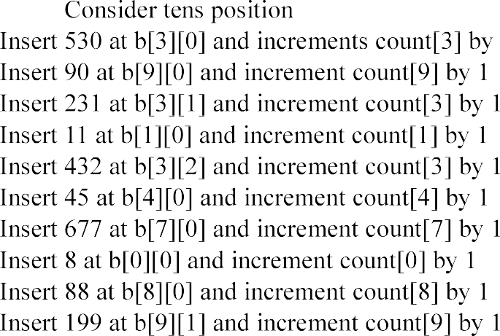

 | Count | b | 0 | 1 | 2 | 3 | 4 | 5 | 6 | 7 | 8 | 9
0 | 1 | 0 | 8
1 | 1 | 1 | 11
2 | 0 | 2
3 | 3 | 3 | 530 | 231 | 432
4 | 1 | 4 | 45
5 | 0 | 5
6 | 0 | 6
7 | 1 | 7 | 677
8 | 1 | 8 | 88
9 | 2 | 9 | 90 | 199

24B11DS069

0 | 1 | 2 | 3 | 4 | 5 | 6 | 7 | 8 | 9
8 | 11 | 530 | 231 | 432 | 45 | 677 | 88 | 90 | 199

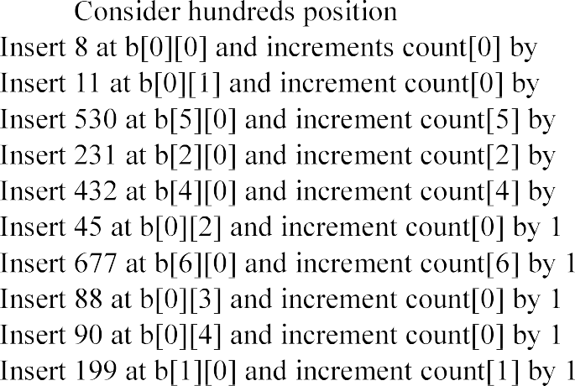

 | Count | b | 0 | 1 | 2 | 3 | 4 | 5 | 6 | 7 | 8 | 9
0 | 5 | 0 | 8 | 11 | 45 | 88 | 90
1 | 1 | 1 | 199
2 | 1 | 2 | 231
3 | 0 | 3
4 | 1 | 4 | 432
5 | 1 | 5 | 530
6 | 1 | 6 | 677
7 | 0 | 7
8 | 0 | 8
9 | 0 | 9
0 | 1 | 2 | 3 | 4 | 5 | 6 | 7 | 8 | 9
8 | 11 | 45 | 88 | 90 | 199 | 231 | 432 | 530 | 677
